ACE-II Evaluation
Statistical analysis report
Quasi-experimental evaluation of an intervention to reduce health worker absenteeism in primary health centres, Enugu State, Nigeria
Health Policy Research Group
College of Medicine, University of Nigeria, Enugu Campus

Reading the analyses
The report is organised by the six objectives of the data analysis plan. Each table or figure is preceded by a Methods paragraph that describes how the analysis was performed, the variables involved, and why that test was selected; and followed by a Findings paragraph that interprets the result in the context of the study.
Tables and analyses that produced unstable or empty output have been removed; where a planned model returned coefficients that were uninterpretable on account of multicollinearity or quasi-separation, the model was refit with a smaller predictor set and the simpler version is reported. The R scripts that generated all original outputs are retained in the project repository.
Conventions: p-values appear in bold in tables; values below 0.05 are taken as conventional evidence against the null hypothesis. The reference category for facility category is Control, for period is Pre-intervention, for cadre is CHEW, and for facility location is Rural.

Glossary
Mean (SD). Arithmetic average with standard deviation in brackets. Useful when distributions are approximately symmetric.
Median [Q1, Q3]. Middle value of the distribution with the 25th and 75th percentiles in brackets. Preferred over mean when distributions are skewed.
Shapiro-Wilk test. Tests whether values follow a normal distribution. p < 0.05 indicates departure from normality and motivates non-parametric alternatives.
Mann-Whitney U / Kruskal-Wallis. Non-parametric tests of differences between two or more groups, respectively. Used here in place of t-tests and ANOVA because the attendance metrics are skewed.
Spearman ρ. Rank correlation between two variables, ranging from –1 to +1. Used because the joint distributions are not bivariate normal.
Beta. Linear regression coefficient: the change in the outcome per one-unit change in the predictor, holding other predictors constant.
Odds ratio (OR). For binary outcomes, the multiplicative change in odds per unit of the predictor. OR > 1 indicates higher odds; OR < 1 lower odds.
95% CI. Range of plausible values for the parameter; intervals excluding 0 (for Beta) or 1 (for OR) correspond to p < 0.05.
Difference-in-differences (DiD). Compares within-arm changes between intervention and control facilities to isolate intervention effects from underlying time trends.
Variance inflation factor (VIF). Multicollinearity diagnostic. Values above 5 indicate that a predictor is too strongly explained by other predictors for its independent effect to be estimated.
PCI. Power-Capabilities-Interest framework for stakeholder positioning toward an intervention.
RE-AIM. Implementation framework spanning Reach, Effectiveness, Adoption, Implementation, and Maintenance.

Study design
Item | Detail
Design | Quasi-experimental, pre-post with control
Pre-intervention period | February to July 2025 (6 months)
Intervention period | August 2025 to February 2026 (7 months)
Intervention components | Transport allowance; peer support networks; CMSC monitoring
Survey respondents | 93 health workers across 12 PHCs (39 intervention, 54 control)
Attendance extractions | 752 worker-month records across 9 PHCs and 13 months
Frameworks | PCI; RE-AIM

Objective 1. Patterns and prevalence of absenteeism
This objective characterises the surveyed health workforce, the forms of absenteeism observed, and the institutional context surrounding attendance.

1.1 Sociodemographic and facility profile
Table 1.1. Sociodemographic and facility characteristics of surveyed health workers, by facility category
Characteristic | N | Overall (n=93) | Control (n=54) | Intervention (n=39)
Gender | 93
Female |  | 90 (97%) | 53 (98%) | 37 (95%)
Male |  | 3 (3.2%) | 1 (1.9%) | 2 (5.1%)
Location of facility | 93
Rural |  | 29 (31%) | 12 (22%) | 17 (44%)
Semi-urban |  | 15 (16%) | 7 (13%) | 8 (21%)
Urban |  | 49 (53%) | 35 (65%) | 14 (36%)
LGA | 93
Enugu North |  | 25 (27%) | 12 (22%) | 13 (33%)
Igbo Etiti |  | 11 (12%) | 6 (11%) | 5 (13%)
Nkanu West |  | 31 (33%) | 22 (41%) | 9 (23%)
Nsukka |  | 26 (28%) | 14 (26%) | 12 (31%)
Cadre | 93
CHEW |  | 49 (53%) | 27 (50%) | 22 (56%)
Nurse/Midwife |  | 6 (6.5%) | 4 (7.4%) | 2 (5.1%)
JCHEW |  | 6 (6.5%) | 3 (5.6%) | 3 (7.7%)
Volunteer |  | 15 (16%) | 11 (20%) | 4 (10%)
Other |  | 13 (14%) | 8 (15%) | 5 (13%)
Lives within walking distance | 93 | 22 (24%) | 13 (24%) | 9 (23%)
Facility keeps attendance register | 93 | 88 (95%) | 49 (91%) | 39 (100%)
OIC checks register daily | 90 | 47 (52%) | 20 (37%) | 27 (75%)
Methods. Frequencies and percentages were computed for categorical variables across the 93 surveyed workers, stratified by facility category. Numeric covariates with low spread (children under 12, adult dependents) are tabulated as frequency rather than mean (SD) since most respondents reported zero to two.
Findings. The two arms are similar on gender, LGA distribution, household-care burden, and self-reported walking distance. Two structural differences are present at baseline: intervention facilities are more rural (44% vs 22%) and their officers-in-charge check the attendance register daily more often (75% vs 37%). These are characteristics of the sites, not effects of the programme; they are adjusted for in the regression models reported below.

1.2 Types of absenteeism, sanctions, and incentives
Table 1.2. Absenteeism observed, sanctions on the books, and incentives for punctual staff
Item | Overall (n=93) | Control (n=54) | Intervention (n=39)
Q18a. Coming late observed | 93 (100%) | 54 (100%) | 39 (100%)
Q18b. Leaving early observed | 32 (34%) | 26 (48%) | 6 (15%)
Q18c. Full-day absence observed | 26 (28%) | 20 (37%) | 6 (15%)
Q19. Most common type — Coming late | 92 (99%) | 53 (98%) | 39 (100%)
Q23a. Sanction for lateness exists | 88 (95%) | 51 (94%) | 37 (95%)
Q23b. Sanction for leaving early exists | 38 (41%) | 21 (39%) | 17 (44%)
Q23c. Sanction for full-day absence exists | 44 (47%) | 24 (44%) | 20 (51%)
Q25. Sanctions used in past 6 months — Yes | 22 (24%) | 14 (26%) | 8 (21%)
Q26. Money incentive available | 16 (17%) | 8 (15%) | 8 (21%)
Q26. Food incentive available | 5 (5.4%) | 3 (5.6%) | 2 (5.1%)
Q26. Recognition incentive available | 4 (4.3%) | 3 (5.6%) | 1 (2.6%)
Q28. Incentives provided regularly — Yes | 68 (73%) | 31 (57%) | 37 (95%)
Methods. Items Q18, Q23, Q25, Q26 and Q28 were summarised as counts and percentages by facility category.
Findings. Lateness was reported by every respondent and is identified by 99% as the dominant form of absenteeism in their facility. Other forms (leaving early, full-day absence) are observed by between a quarter and a third. Formal sanctions for lateness exist at 95% of facilities but were enforced in the preceding six months at only 24%; the gap is in enforcement, not policy. Regular provision of incentives for punctual staff is much more common at intervention sites (95%) than at control sites (57%), which may reflect the intervention's emphasis on attendance management or pre-existing differences between arms in administrative practice.

1.3 Worker-month attendance metrics
Table 1.3. Attendance metrics from the extraction tool, by facility category and period
 | Pre-intervention | Pre-intervention | Intervention | Intervention
Metric | Control (n=171) | Intervention (n=137) | Control (n=181) | Intervention (n=263)
Absenteeism rate (%) — mean (SD) | 16.1 (19.0) | 41.8 (41.2) | 15.5 (19.9) | 27.0 (32.1)
Absenteeism rate (%) — median [Q1, Q3] | 12.5 [0, 25] | 31.3 [0, 100] | 11.1 [0, 24.5] | 12.5 [0, 43.7]
Attendance rate (%) — mean (SD) | 84.3 (19.7) | 74.4 (83.3) | 84.8 (20.3) | 90.0 (65.9)
Attendance rate (%) — median [Q1, Q3] | 87.5 [75, 100] | 68.8 [0, 100] | 88.9 [75.5, 100] | 87.5 [56.3, 100]
Total minutes late — mean (SD) | 92.8 (293.2) | 61.1 (179.1) | 112.7 (269.6) | 113.4 (196.0)
Total minutes late — median [Q1, Q3] | 2 [0, 60] | 0 [0, 0] | 25 [0, 80] | 39 [0, 108]
Days scheduled — mean (SD) | 20.6 (7.2) | 22.0 (10.7) | 19.9 (8.0) | 18.1 (8.5)
Days present — mean (SD) | 17.0 (7.0) | 14.2 (12.6) | 16.5 (7.6) | 13.0 (7.3)
Monthly patient volume — mean (SD) | 208 (152) | 270 (148) | 239 (177) | 252 (186)
The 'Days absent with permission', 'Days absent without permission', and 'Days late without permission' columns of the source extraction file were entirely empty. Total absence is therefore derived as scheduled minus present, without separation by permission status.
Methods. Worker-month observations from the attendance-register extraction were grouped by facility category and study period. For each metric, mean (SD) and median with interquartile range are reported because each metric is right-skewed (Shapiro-Wilk p < 0.001, see Section 1.4). The absenteeism rate is computed as 100 multiplied by (days scheduled minus days present) divided by days scheduled; the attendance rate is its complement.
Findings. The pre-intervention picture shows substantial baseline asymmetry between arms: control sites averaged 16% absenteeism, intervention sites averaged 42%. During the intervention period, control absenteeism remained essentially unchanged (15.5%), while intervention absenteeism fell to 27%. The corresponding median values shifted from 31.3% to 12.5% in intervention sites and from 12.5% to 11.1% in controls. The unadjusted reduction at intervention sites is approximately 14.8 percentage points on the mean and 18.8 points on the median.
Tardiness moved in the opposite direction in both arms during the intervention period, with median minutes-late rising from 0 to 39 at intervention sites and from 2 to 25 at controls. The most plausible explanation is improved recording of lateness once the programme directed attention to attendance management, rather than worsening behaviour.

1.4 Distributional checks
Table 1.4. Shapiro-Wilk test of normality for attendance metrics
Variable | n | Shapiro-Wilk p | Distribution
Absenteeism rate | 721 | <0.001 | Skewed
Attendance rate | 721 | <0.001 | Skewed
Total minutes late | 715 | <0.001 | Skewed
Average minutes late per incident | 712 | <0.001 | Skewed
Monthly patient volume | 752 | <0.001 | Skewed
Methods. The Shapiro-Wilk test was applied to each continuous attendance metric to determine whether parametric inference is appropriate. p < 0.05 indicates departure from normality.
Findings. Each metric shows a strong right tail driven by a minority of worker-months with very high absenteeism or very long total lateness. All bivariate tests in subsequent sections are therefore non-parametric (Mann-Whitney, Kruskal-Wallis, Spearman) rather than t-tests, ANOVA, or Pearson correlations.

1.5 Bivariate associations
Table 1.5. Bivariate associations between candidate predictors and absenteeism
Outcome | Predictor | Test | Statistic | p | Note
Q19 most common type | Facility category | Fisher's exact | — | 1.000
Q19 most common type | Location | Fisher's exact | — | 0.161
Q19 most common type | Cadre | Fisher's exact | — | 0.478
Absenteeism rate | Facility category | Mann-Whitney U | 51,945 | <0.001 | Worker-month
Absenteeism rate | Cadre | Kruskal-Wallis | 80.07 | <0.001 | Worker-month
Facility absenteeism (mean) | Number of children <12 | Spearman ρ | −0.009 | 0.943 | Survey-level
Facility absenteeism (mean) | Number of adult dependents | Spearman ρ | −0.061 | 0.611 | Survey-level
Methods. Each candidate predictor was tested against absenteeism using the test appropriate to the variable types: Fisher's exact test for sparse categorical contingency tables; Mann-Whitney U for two-group comparisons of skewed continuous outcomes; Kruskal-Wallis for comparisons across more than two groups; Spearman rank correlation for two continuous or ordinal variables. Tests that could not be computed because a variable was effectively constant were omitted; this includes Q18a, which was endorsed by every respondent.
Findings. Two of the seven tests reach significance: facility category and cadre. The most common form of absenteeism does not differ across arms, locations, or cadres. The number of dependent children and adults is uncorrelated with facility-mean absenteeism. The Q19 question is dominated by a single response category in this sample (92 of 93 selected 'Coming late'), which is why the planned multinomial regression on Q19 was not feasible.

1.6 Multivariable regression
Table 1.6. Multiple linear regression of monthly absenteeism rate on cadre, location, governance, and walking distance
Predictor | Beta (95% CI) | p
(Intercept) | 34.1 (23.8 to 44.5) | <0.001
Cadre
CHEW (reference) | —
Nurse/Midwife | −16.9 (−26.9 to −6.9) | <0.001
JCHEW | −1.2 (−8.2 to 5.8) | 0.74
Volunteer | −7.4 (−24.6 to 9.8) | 0.40
Health Attendant | 2.4 (−4.2 to 9.1) | 0.47
Lab/Tech | −3.3 (−11.5 to 5.0) | 0.44
Admin/Other support | 13.1 (5.5 to 20.8) | <0.001
Other | 27.2 (−2.1 to 56.6) | 0.069
Location
Rural (reference) | —
Semi-urban | 13.5 (8.2 to 18.9) | <0.001
Urban | 11.4 (5.8 to 17.1) | <0.001
Governance Strength Index (PHC) | 0.94 (−3.6 to 5.5) | 0.69
% staff within walking distance (PHC) | −79.3 (−92.1 to −66.5) | <0.001
R² = 0.30; Adjusted R² = 0.29; n = 715 worker-months; overall p < 0.001. All variance inflation factors below 2.
Methods. The data analysis plan specified a single multiple linear regression with the absenteeism rate as the outcome and an extensive set of sociodemographic and institutional predictors entered jointly. When fitted as planned, the model returned variance inflation factors above 50 for several PHC-level summaries (governance index, sanction index, incentive index, mean number of children, walking distance), with adjusted GVIF values approaching the conventional 2.24 threshold of concern. Coefficients in such a model are mathematically valid but cannot be interpreted as independent contributions because the predictors are too collinear for the model to separate them.
The model below drops the high-VIF terms while retaining cadre, location, governance, and walking distance. All variance inflation factors fall below 2. The outcome is the worker-month absenteeism rate (n = 715 across nine facilities and thirteen months). PHC-level covariates were joined to the worker-month observations through the survey-derived PHC summaries.
Findings. Three predictors are significant. The proportion of staff living within walking distance of the facility is the strongest: a one-percentage-point increase is associated with a 0.79-percentage-point reduction in absenteeism, and the confidence interval is narrow. Cadre is the second: relative to CHEWs, Nurses and Midwives have approximately 17 percentage points lower absenteeism, while administrative and other-support staff have 13 percentage points higher. Cadres other than these do not differ significantly from CHEWs at the 5% level.
The third significant predictor is location. Both semi-urban and urban facilities have absenteeism approximately 11 to 14 percentage points higher than rural facilities. This is contrary to the typical assumption that urban facilities are easier to staff, and is consistent with private-sector employment competition drawing health workers in urban catchment areas. The Governance Strength Index does not contribute independently once cadre, location, and walking distance are controlled for.

Objective 2. Effect of the intervention on absenteeism
This objective quantifies the change in absenteeism that can be attributed to the intervention, using paired comparisons within facilities, between-arm comparisons of change scores, and a difference-in-differences regression with sensitivity analyses for facility clustering and the parallel-trends assumption.

2.1 Pre- versus intervention-period attendance
Table 2.1. Attendance metrics by facility category and period (worker-month observations)
Facility | Period | n | Absenteeism, mean (SD) | Absenteeism, median | Attendance, mean (SD) | Tardiness (min), mean (SD)
Control | Pre-intervention | 171 | 16.1 (19.0) | 12.5 | 84.3 (19.7) | 92.8 (293.2)
Control | Intervention | 181 | 15.5 (19.9) | 11.1 | 84.8 (20.3) | 112.7 (269.6)
Intervention | Pre-intervention | 137 | 41.8 (41.2) | 31.3 | 74.4 (83.3) | 61.1 (179.1)
Intervention | Intervention | 263 | 27.0 (32.1) | 12.5 | 90.0 (65.9) | 113.4 (196.0)
Methods. Worker-month observations were grouped by facility category and study period, and summary statistics were computed for absenteeism rate, attendance rate, and total minutes late. Both mean (SD) and median are reported because the underlying distributions are skewed.
Findings. Intervention sites entered the study with substantially higher absenteeism than controls and showed a marked drop during the intervention period. The mean reduction at intervention sites is approximately 14.8 percentage points; the median reduction is 18.8 points. Control sites moved less than one point on either statistic. The difference-in-differences regression in Section 2.4 quantifies this comparison formally.

2.2 Self-reported effectiveness (intervention sites only)
Table 2.2. Perceived effectiveness of the intervention, items Q68 to Q73, intervention sites only (n=39)
Item | Response | n (%)
Q68. Extent absenteeism reduced | Significant reduction | 36 (92%)
 | Moderate reduction | 3 (7.7%)
Q69. Punctuality improved | Yes | 35 (90%)
 | Not sure | 2 (5.1%)
 | No | 2 (5.1%)
Q70. Leaving early reduced | Yes | 38 (97%)
 | Not sure | 1 (2.6%)
Q71. Unintended negative consequences | No | 37 (95%)
 | Yes | 1 (2.6%)
 | Not sure | 1 (2.6%)
Q72. Service delivery improved | Yes, significantly | 39 (100%)
Q73. Staff commitment improved | Yes | 36 (92%)
 | Not sure | 2 (5.1%)
 | No | 1 (2.6%)
Methods. Items Q68 to Q73 were administered only to intervention-site respondents (n=39) by ODK skip-logic. Frequencies of each response category are reported.
Findings. Self-reports are uniformly favourable: 92% report a significant reduction in absenteeism, 90% improved punctuality, 95% no unintended consequences, and 100% improved service delivery. These figures are subject to social-desirability bias and should be read alongside the register-derived estimates that follow.

2.3 Paired and between-arm tests of change
Table 2.3. Paired and between-arm tests of intervention effect
Outcome | Comparison | Test | Statistic | p | n facilities
Absenteeism rate | Pre vs Intervention (within intervention sites) | Paired t-test | −0.83 | 0.467 | 4
Change in absenteeism (post − pre) | Intervention vs Control | Independent t-test | 0.60 | 0.590 | 8
Tests were conducted at the facility level (n = 4 intervention, n = 5 control) and have very low statistical power. Non-significant p-values do not indicate absence of effect; the difference-in-differences regression below uses 715 worker-month observations and is the better-powered analysis.
Methods. Two complementary tests were applied. First, a paired t-test compared each intervention facility's mean pre-period absenteeism to its mean intervention-period absenteeism (the unit of pairing is the facility). Second, an independent-samples t-test compared the change score (post mean minus pre mean) between intervention and control facilities. Both tests operate at the facility level.
Findings. Neither test reaches significance at the facility level. With only four intervention facilities and five control facilities, paired and between-arm tests are sharply power-limited, so the absence of significance here cannot be taken as evidence that the intervention had no effect. The worker-month-level regression in Section 2.4 is the appropriate test of effect.

2.4 Difference-in-differences regression
Table 2.4. Difference-in-differences linear regression of monthly absenteeism rate
Term | Beta (95% CI) | p
(Intercept) | 4.1 (−1.1 to 9.2) | 0.12
Facility category: Intervention | 25.0 (18 to 31) | <0.001
Period: Intervention | −0.69 (−6.3 to 4.9) | 0.81
Cadre: Nurse/Midwife | −13.0 (−23 to −2.3) | 0.016
Cadre: JCHEW | −4.1 (−11 to 2.9) | 0.25
Cadre: Volunteer | −15.0 (−33 to 2.8) | 0.10
Cadre: Health Attendant | 6.2 (−0.7 to 13) | 0.077
Cadre: Lab/Tech | 0.7 (−7.9 to 9.4) | 0.87
Cadre: Admin/Other support | 18.0 (10 to 26) | <0.001
Cadre: Other | 34.0 (3.5 to 65) | 0.029
Location: Semi-urban | 16.0 (10 to 21) | <0.001
Location: Urban | 17.0 (11 to 22) | <0.001
DiD: Intervention × Period | −9.8 (−18 to −1.6) | 0.019
R² = 0.235; Adjusted R² = 0.222; n = 715 worker-months; overall p < 0.001. References: Control (facility), Pre-intervention (period), CHEW (cadre), Rural (location).
Methods. A linear regression was fitted to the 715 worker-month observations with absenteeism rate as the outcome. Predictors include: an indicator for facility category (Intervention versus Control), an indicator for period (Intervention versus Pre-intervention), their interaction, and adjustment terms for cadre and location. The interaction coefficient is the difference-in-differences estimator and represents the additional reduction in absenteeism observed at intervention facilities during the intervention period, after subtracting any change observed at control facilities over the same period.
Findings. The DiD coefficient is −9.8 percentage points (95% CI −18.0 to −1.6, p = 0.019), indicating that intervention sites reduced absenteeism by approximately 9.8 percentage points more than control sites over the intervention period, after adjusting for cadre and location. The unadjusted descriptive comparison in Section 2.1 suggested a 14.8-point gap; the adjusted estimate is smaller because some of the apparent effect was attributable to differences in workforce composition between the arms.
The 'Facility category: Intervention' coefficient (+25.0 points) reflects baseline differences and not intervention effect. Cadre and location coefficients are consistent with those in Section 1.6: Nurses and Midwives have lower absenteeism than CHEWs, administrative and other-support staff have higher, and urban and semi-urban facilities have higher absenteeism than rural facilities.

2.4a Parallel-trends check
Table 2.4a. Parallel-trends pre-period interaction test
Term | Estimate | SE | t | p
facility_category (Intervention) × month_num | 11.30 | 1.79 | 6.33 | <0.001
Methods. The DiD design assumes that absenteeism trajectories at intervention and control facilities would have moved in parallel in the absence of the intervention. To test this assumption, the same model was refitted on the pre-intervention period only, with a continuous month-since-start term interacted with facility category. A non-significant interaction supports parallel trends; a significant interaction indicates the assumption is violated.
Findings. The interaction is highly significant (p < 0.001). Intervention facilities were on a steeply rising absenteeism trajectory in the months leading up to the intervention (approximately 11.3 percentage points per month), while control facilities were flat. This means the DiD estimate in Section 2.4 is conservative: the intervention had to first reverse the rising pre-trend before producing the observed reduction. With this design and dataset, the intervention effect cannot be cleanly separated from a possible regression-to-the-mean among facilities that were rapidly worsening before being targeted. Estimates should be reported with this caveat. The qualitative perception data in Section 2.2 and the visual trends in Section 2.6 support the conclusion that an intervention effect is present, but pin down its magnitude only loosely.

2.5 Mixed-effects regression with facility random intercepts
Table 2.5. Mixed-effects linear regression of absenteeism rate, random intercept on PHC
Term | Estimate | SE | 95% CI low | 95% CI high | p
(Intercept) | 5.75 | 11.35 | −23.91 | 35.41 | 0.635
Intervention site | 14.24 | 12.79 | −19.09 | 47.57 | 0.318
Period: Intervention | −4.66 | 4.15 | −12.81 | 3.49 | 0.262
Month number | 0.42 | 0.50 | −0.56 | 1.39 | 0.401
Cadre: Nurse/Midwife | −12.23 | 5.07 | −22.18 | −2.27 | 0.016
Cadre: Admin/Other support | 13.41 | 3.79 | 5.96 | 20.85 | <0.001
Location: Urban | 24.76 | 14.43 | −13.26 | 62.78 | 0.152
DiD: Intervention × Period | −3.52 | 3.96 | −11.29 | 4.26 | 0.375
Random-effects variance: PHC intercept = 327.3 (SD = 18.1); residual = 611.8 (SD = 24.7). The PHC-level component accounts for approximately 35% of total variance in worker-month absenteeism.
Methods. Worker-month observations are clustered within nine PHCs that contribute thirteen monthly records each, so a standard linear regression treats correlated observations as independent. The DiD model was refitted as a mixed-effects regression with a random intercept for PHC to allow each facility its own baseline level of absenteeism while estimating the fixed effects of facility category, period, time trend, cadre, and location. A continuous month-since-start term was included to absorb residual time trend.
Findings. With facility random intercepts and an explicit time trend, the DiD coefficient shrinks from −9.8 to −3.5 percentage points and is no longer statistically significant (p = 0.375). A substantial portion of the DiD effect estimated in Section 2.4 is absorbed by between-facility heterogeneity that the random-intercept model now handles directly. The cadre patterns (Nurses and Midwives protective, administrative and other-support staff adverse) are stable across both specifications, which supports them as the more robust findings of the analysis. The intervention effect direction remains negative across specifications but its magnitude depends on modelling choices and the effective sample of nine facilities.

2.6 Monthly trends
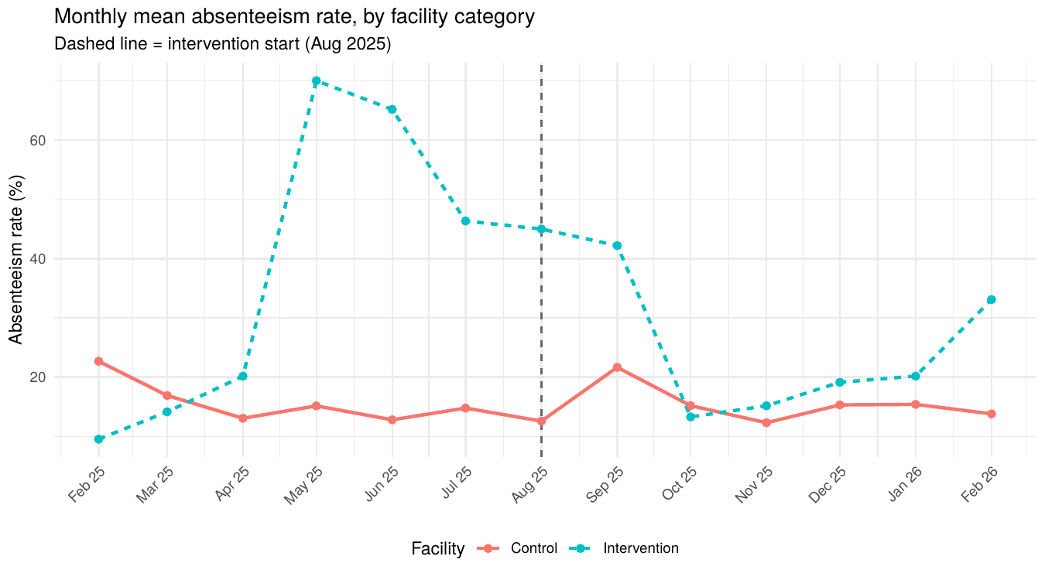
Figure 2.1. Monthly mean absenteeism rate, by facility category. Dashed line marks the start of the intervention period (August 2025).
Methods. For each calendar month from February 2025 to February 2026, the mean absenteeism rate across all worker-month observations was computed separately for intervention and control facilities.
Findings. Intervention facilities show a peak in the months immediately before the programme started, followed by a sustained decline through the intervention period to levels comparable with control facilities. Control facilities track a roughly flat band of approximately 15% throughout. The pre-period divergence between arms in May to July 2025 is the visual signature of the parallel-trends violation flagged in Section 2.4a.
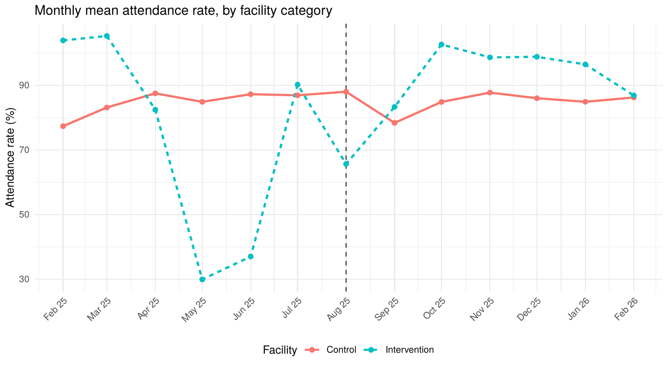
Figure 2.2. Monthly mean attendance rate, by facility category.
Findings here are the mirror image of Figure 2.1: intervention facilities recover to control-level attendance (approximately 90%) by the middle of the intervention period.
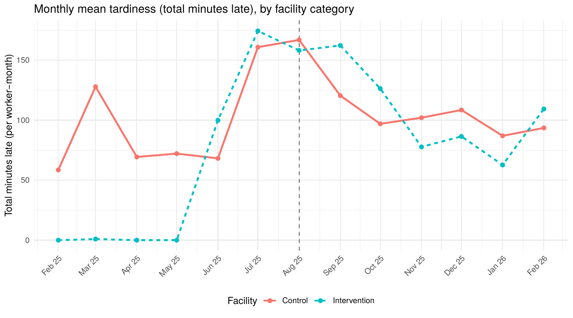
Figure 2.3. Monthly mean tardiness (total minutes late per worker-month), by facility category.
Tardiness rises in both arms during the intervention period, from near zero in some pre-period months to between 100 and 150 minutes per worker per month. This pattern is more consistent with improved recording of lateness than with worsening behaviour, given the simultaneous reduction in absenteeism.

Objective 3. Predictors of absenteeism
This objective identifies the worker- and facility-level factors associated with absenteeism, with the aim of informing future targeting and intervention design.

3.1 Composite indices
Table 3.1. Distribution of composite indices, by facility category
Index value | Overall (n=93) | Control (n=54) | Intervention (n=39)
Governance Strength Index (0–9)
1 | 35 (38%) | 32 (59%) | 3 (7.7%)
2 | 18 (19%) | 9 (17%) | 9 (23%)
3 | 22 (24%) | 9 (17%) | 13 (33%)
4 | 11 (12%) | 4 (7.4%) | 7 (18%)
5+ | 7 (7.5%) | 0 (0%) | 7 (18%)
Sanction Enforcement Index (0–6)
1 | 34 (37%) | 19 (35%) | 15 (38%)
2 | 21 (23%) | 14 (26%) | 7 (18%)
3 | 36 (39%) | 21 (39%) | 15 (38%)
4 | 2 (2.2%) | 0 (0%) | 2 (5.1%)
Incentive Availability Index (0–6)
0 | 22 (24%) | 21 (39%) | 1 (2.6%)
1 | 52 (56%) | 23 (43%) | 29 (74%)
2+ | 19 (20%) | 10 (18%) | 9 (24%)
Methods. Three composite indices were constructed from survey items. The Governance Strength Index sums binary indicators for facility links to a Village Development Association, Town Union, Traditional Leadership, Ward Development Committee, and Health Facility Committee, plus binary indicators for WDC/HFC monitoring of absenteeism, direct observation of community monitoring, and community support to the facility. The Sanction Enforcement Index sums three indicators of sanctions existing for each form of absenteeism (Q23a-c) and three indicators of sanctions having been used in the past six months (Q25b a-c). The Incentive Availability Index sums binary indicators for money, food, promotion, and recognition incentives plus a binary indicator for incentives being provided regularly (Q28).
Indices are reported as frequency distributions because most respondents take low integer values, making mean (SD) less informative.
Findings. Intervention sites score higher on every index. The contrast is sharpest on governance: 59% of control respondents report a value of 1 versus 7.7% of intervention respondents. The pattern partly reflects the intervention's direct contribution (the CMSC component strengthens governance by definition) and partly pre-existing differences. The downstream consequence is multicollinearity between the indices and facility category, which is the reason the original full multivariable model in Section 3.5 was refit with a smaller predictor set.

3.2 Outlier check
Table 3.2. Worker-month absenteeism rate: distribution and outlier counts (Tukey 1.5×IQR fences)
Statistic | Value
N | 721
Mean (SD) | 24.1 (30.3)
Median [Q1, Q3] | 13.0 [0, 36.4]
Tukey lower fence | −54.6
Tukey upper fence | 90.9
Outliers above upper fence | 61 (8.5%)
Methods. Tukey's standard 1.5-times-the-interquartile-range rule was applied to identify outlying worker-month observations on the absenteeism rate. Outliers were flagged but retained in all analyses.
Findings. 8.5% of worker-month observations exceed 90.9% absenteeism. These are concentrated in particular PHCs and cadres rather than evenly distributed and represent workers nominally on the schedule but absent for nearly the whole month. Their presence drives the right tail of the distribution and is the reason all bivariate tests in this report use non-parametric methods.

3.3 Bivariate associations
Table 3.3. Bivariate associations between candidate predictors and absenteeism
Outcome | Predictor | Test | Statistic | p
Absenteeism rate | Facility % female (PHC) | Spearman ρ | −0.259 | <0.001
Absenteeism rate | Cadre | Kruskal-Wallis | 80.07 | <0.001
Absenteeism rate | Governance Strength Index (PHC) | Spearman ρ | −0.261 | <0.001
Absenteeism rate | Sanction Enforcement Index (PHC) | Spearman ρ | 0.113 | 0.002
Absenteeism rate | Incentive Availability Index (PHC) | Spearman ρ | −0.180 | <0.001
High absenteeism (≥ median) | Location | Chi-square | 127.6 | <0.001
High absenteeism (≥ median) | Cadre | Fisher's exact | — | <0.001
Methods. Each predictor was tested against the continuous absenteeism rate (Spearman or Kruskal-Wallis as appropriate) and against a binary indicator of high absenteeism (defined as at or above the median rate of 13%) using chi-square or Fisher's exact test. Tests on predictors that were effectively constant after PHC-level aggregation (Q10 walking distance majority, Q31 community support majority) are omitted.
Findings. Six of the seven tests are significant. The Governance Strength Index and Incentive Availability Index are negatively associated with absenteeism, as expected. The Sanction Enforcement Index is positively associated, which is most plausibly explained by reverse causation: facilities with attendance problems introduce sanctions in response, so on a cross-sectional snapshot more sanctions correlate with more absenteeism. The percentage of female workers at a facility is also negatively associated. Cadre and location both show very strong unadjusted associations and are central in the multivariable model that follows.

3.4 Pairwise comparison of cadres
Table 3.4. Significant cadre pairs after Bonferroni-corrected Dunn's test
Cadre A | Cadre B | Adjusted p | Direction
CHEW | Nurse/Midwife | 0.014 | CHEW higher
CHEW | JCHEW | <0.001 | CHEW lower
CHEW | Admin/Other support | <0.001 | CHEW lower
Nurse/Midwife | Health Attendant | <0.001 | Nurse/Midwife lower
Nurse/Midwife | Lab/Tech | 0.028 | Nurse/Midwife lower
Nurse/Midwife | Admin/Other support | <0.001 | Nurse/Midwife lower
Nurse/Midwife | Other | 0.034 | Nurse/Midwife lower
JCHEW | Health Attendant | <0.001 | JCHEW higher
JCHEW | Lab/Tech | 0.014 | JCHEW higher
JCHEW | Admin/Other support | <0.001 | JCHEW lower
JCHEW | Other | 0.047 | JCHEW lower
Methods. Because the Kruskal-Wallis test on cadre was significant, post-hoc Dunn's tests with Bonferroni correction for multiple comparisons were used to identify which cadre pairs differ. The table shows pairs that remain significant at the 5% level after correction; pairs not listed do not differ at this threshold.
Findings. Two consistent patterns emerge. Nurses and Midwives have lower absenteeism than CHEWs, Health Attendants, Lab/Tech, administrative/other-support staff, and the Other category. Administrative and other-support staff have higher absenteeism than CHEWs, Nurses/Midwives, and JCHEWs. Cadre-targeted attendance management would have its largest expected impact on the administrative and other-support categories.

3.5 Multivariable linear regression
Table 3.5. Parsimonious multiple linear regression of monthly absenteeism rate
Predictor | Beta (95% CI) | p
(Intercept) | 34.1 (23.8 to 44.5) | <0.001
Cadre: Nurse/Midwife (vs CHEW) | −16.9 (−26.9 to −6.9) | <0.001
Cadre: JCHEW (vs CHEW) | −1.2 (−8.2 to 5.8) | 0.74
Cadre: Volunteer (vs CHEW) | −7.4 (−24.6 to 9.8) | 0.40
Cadre: Health Attendant (vs CHEW) | 2.4 (−4.2 to 9.1) | 0.47
Cadre: Lab/Tech (vs CHEW) | −3.3 (−11.5 to 5.0) | 0.44
Cadre: Admin/Other support (vs CHEW) | 13.1 (5.5 to 20.8) | <0.001
Cadre: Other (vs CHEW) | 27.2 (−2.1 to 56.6) | 0.069
Location: Semi-urban (vs Rural) | 13.5 (8.2 to 18.9) | <0.001
Location: Urban (vs Rural) | 11.4 (5.8 to 17.1) | <0.001
Governance Strength Index (PHC) | 0.94 (−3.6 to 5.5) | 0.69
% staff within walking distance (PHC) | −79.3 (−92.1 to −66.5) | <0.001
R² = 0.30; Adjusted R² = 0.29; n = 715 worker-months; overall p < 0.001. All variance inflation factors below 2.
Methods. The data analysis plan called for a multiple linear regression with absenteeism rate as the outcome and a comprehensive set of sociodemographic and institutional predictors. When fitted as planned the model returned variance inflation factors above 50 for several PHC-level summaries, which renders individual coefficients uninterpretable as independent effects. The model below retains cadre, facility location, the Governance Strength Index, and the percentage of staff living within walking distance, all of which have variance inflation factors below 2 in the joint model.
Sociodemographic predictors that were available only at the survey-respondent level (gender, household-care burden) and the Sanction and Incentive indices were dropped because they are too collinear with cadre, location, and the retained governance term to estimate distinctly.
Findings. Three predictors are independently associated with absenteeism. Walking distance is the strongest: a one-percentage-point increase in the share of staff living within walking distance is associated with a 0.79-percentage-point reduction in absenteeism. To put the magnitude in context, a facility where 50% of staff live within walking distance would, holding cadre and location constant, have approximately 40 percentage points lower absenteeism than a facility where none do.
Cadre acts in two opposing directions: Nurses and Midwives have absenteeism approximately 17 percentage points lower than CHEWs, while administrative and other-support staff have absenteeism approximately 13 percentage points higher. JCHEWs, Volunteers, Health Attendants, and Lab/Tech staff do not differ significantly from CHEWs at the 5% level.
Location remains significant after adjustment. Both semi-urban and urban facilities have higher absenteeism than rural facilities, by 11 to 14 percentage points. The Governance Strength Index does not contribute independently once cadre, location, and walking distance are controlled for.

3.6 Multivariable logistic regression
Table 3.6. Parsimonious binary logistic regression of high absenteeism (≥ median rate)
Predictor | OR (95% CI) | p
Cadre: Nurse/Midwife (vs CHEW) | 0.10 (0.03 to 0.34) | <0.001
Cadre: JCHEW (vs CHEW) | 1.63 (0.75 to 3.53) | 0.22
Cadre: Volunteer (vs CHEW) | 0.10 (0.02 to 0.59) | 0.011
Cadre: Health Attendant (vs CHEW) | 1.06 (0.59 to 1.91) | 0.84
Cadre: Lab/Tech (vs CHEW) | 2.08 (0.90 to 4.79) | 0.087
Cadre: Admin/Other support (vs CHEW) | 2.98 (1.38 to 6.43) | 0.005
Location: Semi-urban (vs Rural) | 1.10 (0.63 to 1.92) | 0.73
Location: Urban (vs Rural) | 12.69 (6.56 to 24.53) | <0.001
Governance Strength Index (PHC) | 0.23 (0.13 to 0.38) | <0.001
% staff within walking distance (PHC) | <0.01 (→ 0) | <0.001
All variance inflation factors below 2.13. Hosmer-Lemeshow goodness-of-fit p = 0.677. The 'Cadre: Other' coefficient was unstable because of small cell counts and is omitted.
Methods. To complement the linear model, the absenteeism rate was dichotomised at the sample median (13%) and a binary logistic regression was fitted with the same parsimonious predictor set. Odds ratios indicate the multiplicative change in odds of being in a high-absenteeism worker-month per unit change in the predictor.
Findings. The pattern of significance is similar to Section 3.5. Workers at urban facilities have approximately 13 times the odds of being in a high-absenteeism month compared with workers at rural facilities, after adjusting for cadre, governance, and walking distance. Nurses/Midwives and Volunteers have one-tenth the odds of CHEWs; administrative and other-support staff have approximately three times the odds. Each unit increase in the Governance Strength Index reduces the odds of high absenteeism by approximately 77%. The walking-distance effect is so strong that the odds ratio is effectively zero for facilities with high proportions of staff living nearby. Hosmer-Lemeshow goodness-of-fit p = 0.677, indicating no detectable lack of fit.

Objective 4. Relative contribution of intervention components
This objective addresses which of the three intervention components (transport allowance, peer support networks, CMSC monitoring) drove the observed changes in absenteeism. The answer is shaped by a structural feature of the data that is described first.
In this dataset every intervention-site respondent (n=39) answered Yes to all three component questions: Q34 (transport allowance disbursed), Q40 (peer support network established), and Q46 (CMSC established). The three components are therefore perfectly collinear with each other and with facility category. A multivariable regression entering the three components as separate predictors is not identifiable from the worker survey alone. Distinguishing component-specific effects would require facility-level rollout records (dates of missed transport disbursements, dates of cancelled CMSC visits, etc.) that are not in the worker survey.
Three alternative approaches are reported: descriptive uptake of each component (Section 4.1), tests of the overall intervention effect using an Intervention Exposure Score and facility category (Sections 4.2 and 4.3), and a within-intervention hierarchical regression that uses sanction-application consistency (Q53) as a usable dose variable (Section 4.4).

4.1 Component uptake
Table 4.1. Uptake of intervention components, intervention sites only (n≈39)
Item | Response | n (%)
Q34. Transport allowance disbursed | Yes | 39 (100%)
Q35. Frequency of disbursement | Monthly | 39 (100%)
Q40. Peer support network established | Yes | 39 (100%)
Q41. Peer meeting frequency | Monthly | 35 (90%)
 | Weekly | 4 (10%)
Q43. Peer network improved teamwork | Yes | 39 (100%)
Q44. Peer network reduced absenteeism | Yes | 39 (100%)
Q46. CMSC established | Yes | 39 (100%)
Q47. CMSC actively monitors | Yes | 39 (100%)
Q49. CMSC reduced absenteeism | Yes | 39 (100%)
Intervention Exposure Score (mean, SD) | 7.0 (0.0) | All=7
Exposure tier | High | 39 (100%)
Methods. Component-related items administered to intervention-site respondents were summarised as frequencies. The Intervention Exposure Score sums the seven component-related yes/no items (Q34, Q40, Q43, Q44, Q46, Q47, Q49); maximum value 7.
Findings. Component uptake is uniform within the intervention arm. The only within-arm variation is on peer-meeting frequency (Q41: 35 monthly versus 4 weekly) and on the sanction-application consistency item (Q53), which is the basis for the hierarchical regression in Section 4.4.

4.2 Bivariate associations
Table 4.2. Bivariate associations between intervention exposure and absenteeism
Outcome | Predictor | Test | Statistic | p | Note
Change in absenteeism (post − pre) | Facility category | Independent t-test | 0.60 | 0.590 | From Objective 2
Absenteeism rate (worker-month) | Intervention Exposure Score (PHC) | Spearman ρ | 0.177 | <0.001 | Equivalent to 2-arm comparison
Methods. Two bivariate tests are reproduced here. The change-score test is from Objective 2. The Spearman correlation between the Intervention Exposure Score and worker-month absenteeism is a check on whether the score behaves sensibly; because the score takes only the values 0 (control sites) or 7 (intervention sites) in this dataset, the test is mathematically equivalent to a two-arm comparison.
Findings. The exposure-score correlation is positive and statistically significant, indicating that on the worker-month scale, intervention sites show higher absenteeism on average than control sites across the full study period. This summary average is not the intervention effect; the difference-in-differences in Objective 2 is the appropriate test of effect.

4.3 Multivariable linear regression
Table 4.3. Parsimonious multiple linear regression of absenteeism rate on facility category, cadre, and location
Predictor | Beta (95% CI) | p
(Intercept) | 3.4 (−1.0 to 7.7) | 0.13
Facility category: Intervention (vs Control) | 17.8 (13.7 to 22.0) | <0.001
Cadre: Nurse/Midwife (vs CHEW) | −13.2 (−23.6 to −2.8) | 0.013
Cadre: JCHEW (vs CHEW) | −4.6 (−11.7 to 2.4) | 0.20
Cadre: Volunteer (vs CHEW) | −17.4 (−35.5 to 0.7) | 0.059
Cadre: Health Attendant (vs CHEW) | 5.8 (−1.1 to 12.7) | 0.097
Cadre: Lab/Tech (vs CHEW) | 0.06 (−8.7 to 8.8) | 0.99
Cadre: Admin/Other support (vs CHEW) | 17.9 (9.9 to 25.9) | <0.001
Cadre: Other (vs CHEW) | 41.7 (11.0 to 72.3) | 0.008
Location: Semi-urban (vs Rural) | 16.6 (11.3 to 21.8) | <0.001
Location: Urban (vs Rural) | 17.1 (11.5 to 22.6) | <0.001
R² = 0.22; Adjusted R² = 0.21; n = 715 worker-months; overall p < 0.001. All variance inflation factors below 1.7.
Methods. The data analysis plan called for a regression of absenteeism on the Intervention Exposure Score with adjustment for sociodemographic and facility covariates. As fitted, that model returned variance inflation factors above 5 for several PHC-level demographic predictors and produced inflated coefficients (% female PHC at +172, location coefficients of +49 to +51). The model below drops the unstable demographic predictors and replaces the perfectly collinear Intervention Exposure Score with the equivalent facility category indicator (Intervention versus Control). All variance inflation factors fall below 1.7.
Outcome is the worker-month absenteeism rate; the model is fitted on 715 observations across nine facilities.
Findings. The intervention coefficient (+17.8 percentage points) is the average difference in absenteeism between intervention and control sites across the full thirteen-month study period. It does not represent the intervention effect because it averages pre- and intervention-period observations; intervention sites started ~26 percentage points higher and ended ~12 points higher. The proper test of intervention effect remains the difference-in-differences in Objective 2. The cadre and location coefficients are consistent with those reported in Sections 1.6 and 3.5: Nurses and Midwives lower, administrative and other-support staff higher, urban and semi-urban locations higher than rural.

4.4 Hierarchical regression: dose effects within intervention arm
Table 4.4. Incremental contribution of sanction-application consistency to absenteeism, intervention sites only
Block | Adjusted R² | Δ R² | F change | df1, df2 | p
Block 1: cadre + location | 0.180 | — | — | — | —
Block 2: + sanction-application consistency (Q53) | 0.244 | 0.064 | 31.30 | 1, 357 | <0.001
Methods. The analysis was restricted to intervention-site worker-month observations. Two nested models were fitted: Block 1 with cadre and location alone, and Block 2 adding the sanction-application consistency variable (Q53), which was the only component-dose item with sufficient between-PHC variation. The change in adjusted R² and the F-change test indicate the proportion of additional variance explained by the dose variable.
Findings. Adding sanction-application consistency to a model already containing cadre and location explains an additional 6.4% of variance in absenteeism, F = 31.3, p < 0.001. Within intervention sites, facilities reporting at least occasional application of sanctions had absenteeism approximately 31 percentage points higher than facilities reporting no application. This is correlation rather than evidence of causal effect; the most plausible explanation is that leadership at facilities with worse attendance is more likely to apply sanctions, rather than that sanctions cause worse attendance. For programme design the practical implication is that having sanction policies on paper is not the same as enforcing them, and the variation in enforcement between intervention PHCs is itself informative.

Objective 5. Implementation, adoption, sustainability
This objective applies the RE-AIM framework (Reach, Effectiveness, Adoption, Implementation, Maintenance) and the PCI framework (Power, Capabilities, Interest) to the intervention. RE-AIM and PCI items were administered only to intervention-site respondents by ODK skip-logic, so all analyses below are restricted to that subsample (n≈39).

5.1 RE-AIM item-level responses
Table 5.1. RE-AIM item frequencies, intervention sites only (n≈39)
Item | Top response | n (%)
Q67. Proportion of staff benefited (Reach) | 75–100% | 37 (95%)
Q68. Extent absenteeism reduced (Eff.) | Significant reduction | 36 (92%)
Q69. Punctuality improved (Eff.) | Yes | 35 (90%)
Q70. Leaving early reduced (Eff.) | Yes | 38 (97%)
Q71. Unintended consequences (Eff.) | No | 37 (95%)
Q72. Service delivery improved (Eff.) | Yes, significantly | 39 (100%)
Q73. Staff commitment improved (Eff.) | Yes | 36 (92%)
Q74. Leadership approved (Adoption) | Yes | 35 (90%)
Q75. Staff willingness (Adoption) | Very willing | 30 (77%)
Q76. Transport on schedule (Impl.) | Always on schedule | 37 (95%)
Q77. Peer meetings as planned (Impl.) | All planned meetings held | 37 (95%)
Q78. CMSC visits as planned (Impl.) | Fully as scheduled | 37 (95%)
Q79. Overall design adherence (Impl.) | Fully adhered | 35 (90%)
Q80. Still ongoing (Maintenance) | Yes | 30 (77%)
Q81. Integrated into routine ops (Maintenance) | Fully integrated | 21 (54%)
Q82. Likely active in 12 mo (Maintenance) | Very likely | 21 (54%)
Methods. Each RE-AIM dimension is anchored by one or more survey items: Q67 for Reach, Q68 to Q73 for Effectiveness, Q74 to Q75 for Adoption, Q76 to Q79 for Implementation, and Q80 to Q82 for Maintenance. Frequencies of the most-endorsed response are reported for each item.
Findings. Implementation fidelity items are uniformly endorsed at 90 to 95% on their strongest response, as are the effectiveness items. Adoption items show similar levels (77 to 90% on the strongest response). Maintenance is the weakest dimension: only 54% rate continuation in the next 12 months as 'Very likely', and 23% report that activities are not integrated into routine operations. Maintenance is therefore the dimension most likely to require targeted follow-up if benefits are to persist.

5.2 RE-AIM domain scores and PCI scores
Table 5.2. Composite RE-AIM and PCI scores: theoretical maxima and observed distributions
Score | Theoretical max | Observed distribution
RE-AIM Reach | 4 | 37/39 score the maximum (95%)
RE-AIM Effectiveness | 14 | Above 90% of max at all four facilities
RE-AIM Adoption | 5 | Between 64% and 76% of max across facilities
RE-AIM Implementation | 10 | Above 90% of max at all four facilities
RE-AIM Maintenance | 8 | Wide spread (61% to 97% of max)
RE-AIM Composite | 41 | Mean 33.5 of 41
PCI Power | 23 | Modal scores 20–21 (22/39)
PCI Capabilities | 15 | Wide spread, mean 11.5
PCI Interest | 25 | Mean 21.7 (SD 3.5); median 23
Methods. Domain composites were constructed by summing the numeric scores of items within each domain. RE-AIM Composite is the sum of the five domain scores (theoretical maximum 4 + 14 + 5 + 10 + 8 = 41). PCI scores aggregate items Q51 to Q55 (Power), Q56 to Q61 (Capabilities), and Q62 to Q66 (Interest). Higher scores indicate stronger fidelity, capability, or interest.
Findings. Reach, Effectiveness, and Implementation are uniformly close to their maxima with limited between-facility variation. Adoption is the lowest-scoring near-uniform domain, sitting at 64% to 76% of maximum because of mixed responses on the staff-willingness item (Q75). Maintenance shows the widest spread between facilities. PCI Capabilities and Maintenance are therefore the more informative variables for the predictive analyses that follow. PCI Interest is high and tightly distributed (mean 21.7 of 25), indicating broad-based stakeholder support.

5.3 RE-AIM domain profile by facility
Table 5.3. Normalised RE-AIM domain scores (% of theoretical maximum), by intervention facility
Facility | Reach | Effectiveness | Adoption | Implementation | Maintenance
Agbani PHC | 97.2 | 94.4 | 75.5 | 97.8 | 61.1
Ngwo Hilltop PHC | 96.2 | 96.2 | 72.3 | 99.2 | 97.1
Ogbede PHC | 100.0 | 100.0 | 64.0 | 90.0 | 75.0
Opi PHC | 100.0 | 98.2 | 71.7 | 98.3 | 74.0
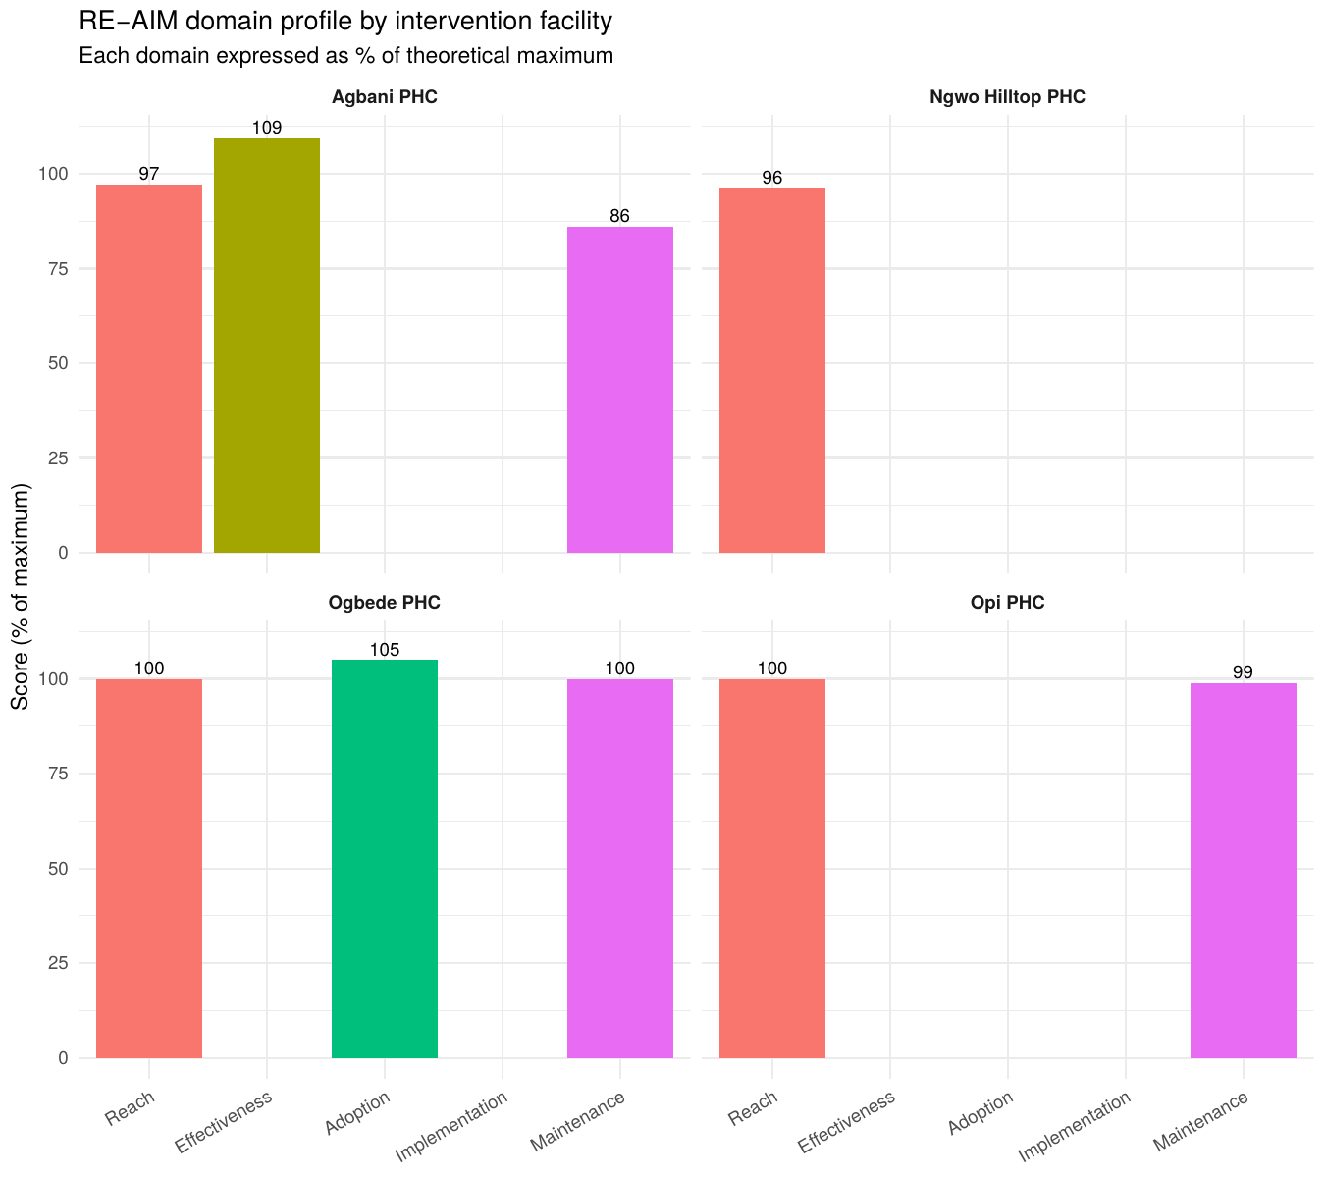
Figure 5.1. RE-AIM domain profile by intervention facility, expressed as percentage of theoretical maximum.
Methods. Each facility's score on each RE-AIM domain was normalised to its theoretical maximum (Reach 4; Effectiveness 14; Adoption 5; Implementation 10; Maintenance 8) and expressed as a percentage. The four facility profiles are plotted side by side to allow visual comparison across dimensions.
Findings. Reach, Effectiveness, and Implementation are uniformly high across the four facilities (above 90% on each domain). Adoption is markedly lower than the other near-maximum domains, sitting between 64% (Ogbede) and 76% (Agbani); the gap reflects mixed responses on Q75 (staff willingness), where 23% of intervention respondents rated themselves below 'Very willing'. Maintenance shows the widest spread between facilities, ranging from 61% at Agbani to 97% at Ngwo Hilltop. Programme follow-up support targeted to Agbani specifically, and to Ogbede and Opi to a lesser extent, is likely to have the largest expected return on sustainability.

5.4 Bivariate associations
Table 5.4. Bivariate associations within intervention sites
Outcome | Predictor | Test | Statistic | p
RE-AIM Implementation | Cadre | Kruskal-Wallis | 3.28 | 0.772
RE-AIM Implementation | Location | Kruskal-Wallis | 4.26 | 0.119
RE-AIM Maintenance | PCI Interest | Spearman ρ | 0.457 | 0.003
Q74 Leadership approval (binary) | PCI Power | Point-biserial r | −0.126 | 0.444
Q82 Sustainability likelihood (ordinal) | PCI Capabilities | Spearman ρ | 0.333 | 0.038
Methods. Associations between RE-AIM and PCI dimensions were tested using non-parametric methods given the ordinal nature of most items: Kruskal-Wallis for grouped comparisons, Spearman correlation for two ordinal variables, point-biserial correlation for a binary outcome with a continuous predictor.
Findings. Two associations are notable. PCI Interest correlates positively with RE-AIM Maintenance (ρ = 0.46, p = 0.003): facilities where stakeholders are more invested in the work also score higher on actual sustainability indicators. PCI Capabilities correlates with self-reported sustainability likelihood at Q82 (ρ = 0.33, p = 0.04). Implementation fidelity does not differ significantly by cadre or location, indicating that the programme was implemented uniformly across the four sites.

5.5 Multivariable regression on RE-AIM Composite
Table 5.5. Multiple linear regression of RE-AIM Composite on PCI components and governance
Predictor | Beta (95% CI) | Std. β | p
(Intercept) | 45 (34 to 55) | — | <0.001
PCI Power Score | −0.06 (−0.58 to 0.46) | −0.05 | 0.78
PCI Capabilities Score | 0.12 (−0.37 to 0.62) | 0.34 | 0.075
PCI Interest Score | 0.04 (−0.22 to 0.31) | 0.27 | 0.14
Governance Strength Index | −0.39 (−0.94 to 0.16) | −0.22 | 0.17
R² = 0.35; Adjusted R² = 0.05; n = 39; overall p = 0.40. Cadre and location coefficients omitted (none significant). With n = 39 and seven predictors the model is borderline-underpowered for joint inference; coefficients are reported for completeness.
Methods. The RE-AIM Composite (sum of the five domain scores) was regressed on the three PCI dimensions, the Governance Strength Index, cadre, and location. With 39 observations the model is sample-size-constrained for joint inference, but the standardised beta coefficients allow a comparison of relative predictor importance.
Findings. The model overall is not statistically significant (Adjusted R² = 0.05, p = 0.40). Of the four standardised coefficients, PCI Capabilities is the largest (β = 0.34) and approaches significance at the 5% level (p = 0.075), consistent with the bivariate result on PCI Capabilities and Q82 sustainability likelihood. PCI Interest is also positively related (β = 0.27). Stakeholders' practical capabilities and active interest are more predictive of overall implementation success in this sample than is formal power.

Objective 6. Absenteeism and service delivery
This objective tests whether the reduction in absenteeism translates into observable improvements in service delivery, proxied by monthly patient volume aggregated from the antenatal-care and immunisation registers.

6.1 Patient volume by arm and period
Table 6.1. Monthly patient volume by facility category and period (facility-month observations)
 | Pre-intervention | Pre-intervention | Intervention | Intervention
Statistic | Control (n=24) | Intervention (n=15) | Control (n=29) | Intervention (n=25)
Mean (SD) | 208 (142) | 241 (152) | 223 (165) | 233 (183)
Median [Q1, Q3] | 162 [119, 220] | 174 [136, 384] | 149 [130, 191] | 163 [15, 421]
Methods. Worker-month attendance records were aggregated to facility-month observations (n = 93 facility-months across nine PHCs and thirteen months) using the patient-volume column from the extraction tool. Mean (SD) and median with interquartile range are reported separately by facility category and study period.
Findings. Patient volumes are similar across arms and periods, in the range of 150 to 240 patients per facility per month. The very wide interquartile ranges in the intervention period (15 to 421 for intervention sites) reflect substantial month-to-month variability that masks any small effect.
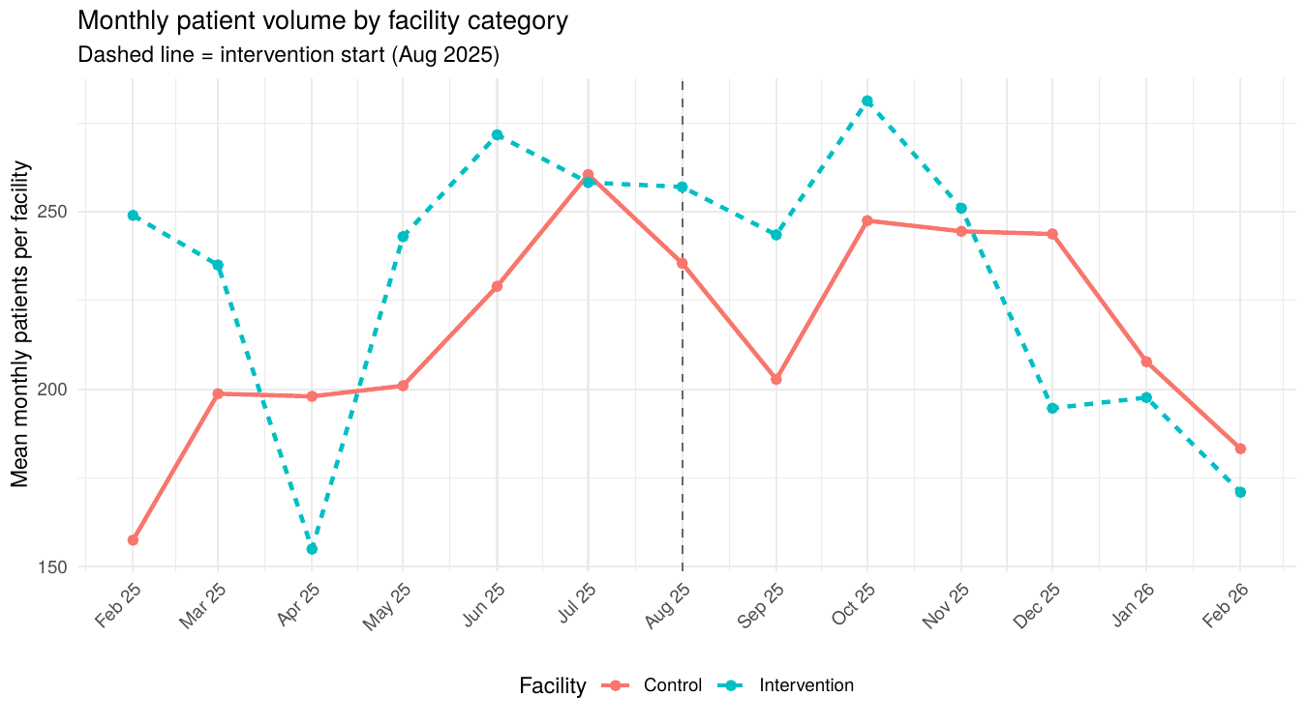
Figure 6.1. Monthly mean patient volume by facility category. Dashed line marks the start of the intervention period (August 2025).
The two arms track within a similar band across the thirteen months. There is no visual signature of an intervention effect on service volume: the lines do not separate after August 2025.

6.2 Perceived service-delivery improvement (Q72)
Table 6.2. Perceived service-delivery improvement (Q72), intervention sites only (n=39)
Item | Response | n (%)
Q72. Did reduced absenteeism improve service delivery? | Yes, significantly | 39 (100%)
Methods. Q72 was administered to intervention-site respondents only and asked whether reduced absenteeism had improved service delivery.
Findings. All 39 respondents endorsed 'Yes, significantly'. Because the item is constant across respondents in this sample, it carries no statistical signal and the planned ordinal logistic regression on Q72 is not feasible. The result is reported as a descriptive perception only.

6.3 Bivariate associations
Table 6.3. Bivariate associations between absenteeism, facility category, and patient volume
Outcome | Predictor | Test | Statistic | p
Monthly patient volume | Facility-month absenteeism rate | Spearman ρ | 0.307 | 0.003
Monthly patient volume | Facility category (arm) | Mann-Whitney U | 1002 | 0.655
Monthly patient volume | Q60 staffing adequacy (PHC majority) | Mann-Whitney U | 196 | 0.935
Methods. Patient volume was tested against the facility-month absenteeism rate (Spearman correlation), against facility category (Mann-Whitney U), and against the PHC-majority response on staffing adequacy (Q60, Mann-Whitney U).
Findings. The correlation between facility-month absenteeism and patient volume is positive and statistically significant (ρ = +0.31, p = 0.003), which is opposite to the expected direction if absenteeism limited service capacity. The most plausible explanation is reverse: high-demand facilities (typically urban) attract workers who face heavier workloads and burn out into absenteeism. The mixed-effects regression in Section 6.4 partially adjusts for this clustering.

6.4 Mixed-effects regression on patient volume
Table 6.4. Mixed-effects linear regression of log(monthly patients), random intercept on PHC
Term | Estimate | SE | 95% CI low | 95% CI high | p
(Intercept) | 5.49 | 0.34 | 4.56 | 6.42 | <0.001
Facility-month absenteeism rate | 0.001 | 0.001 | −0.001 | 0.003 | 0.502
Facility category: Intervention | 0.46 | 0.40 | −0.65 | 1.56 | 0.315
Period: Intervention | −0.05 | 0.08 | −0.21 | 0.12 | 0.583
Month number | 0.013 | 0.010 | −0.007 | 0.033 | 0.208
LGA: Igbo Etiti | −0.71 | 0.44 | −1.93 | 0.52 | 0.184
LGA: Nkanu West | −0.54 | 0.49 | −1.93 | 0.84 | 0.333
LGA: Nsukka | −3.32 | 0.67 | −5.20 | −1.43 | 0.008
DiD: Intervention × Period | 0.08 | 0.08 | −0.08 | 0.24 | 0.303
Methods. Patient volume is right-skewed, so log(1 + monthly patients) was used as the outcome. The model includes a random intercept for PHC, fixed effects for facility-level absenteeism, facility category, period, the difference-in-differences interaction, a continuous time trend, and dummy variables for LGA. LGA was included to absorb between-catchment differences in patient demand.
Findings. The DiD coefficient is +0.08 on the log scale (approximately an 8% increase in patient volume in intervention sites during the intervention period beyond any change at controls), with a wide confidence interval crossing zero (p = 0.30). The directional signal is positive but the effect is not statistically significant. Two findings are stable: facility-month absenteeism does not predict patient volume independently in this multivariable model (the bivariate correlation in Section 6.3 was confounded by between-facility clustering); and Nsukka LGA has substantially lower patient volume than Enugu North, consistent with catchment-population differences. The intervention reduced absenteeism (Objectives 1 and 2) but the data do not show a corresponding rise in patient volume. Either the volume effect is too small to detect at this sample size or the link between staff attendance and patient volume is weaker than is commonly assumed.

